The World

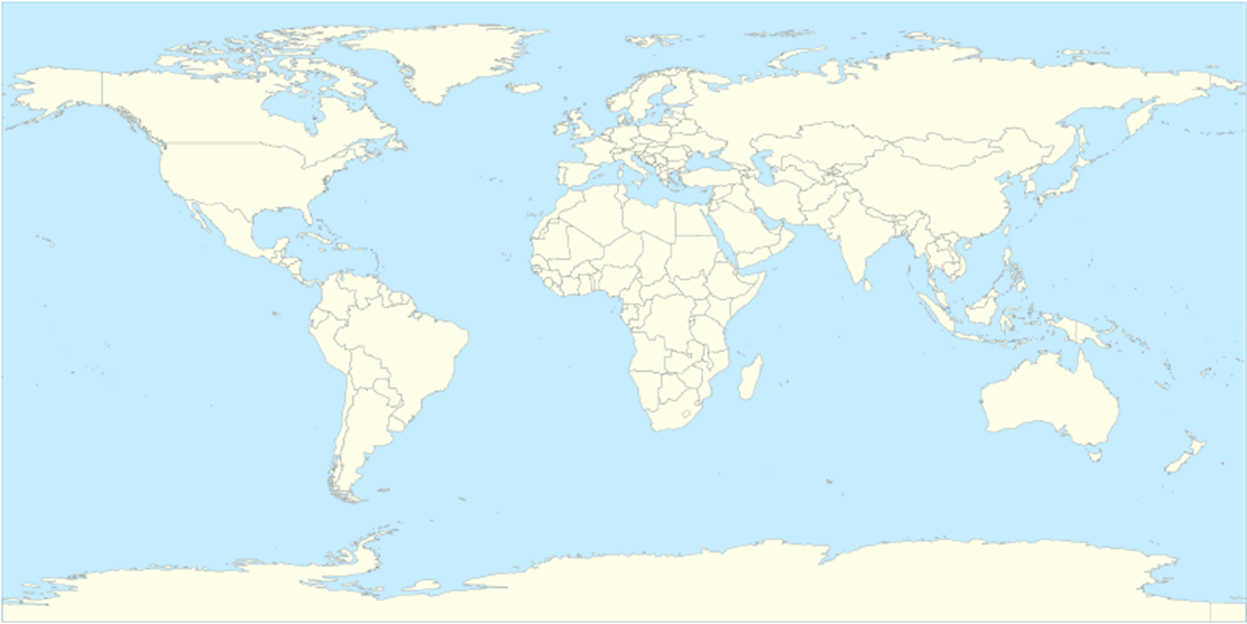

Map used courtesy Gringer, released into the public domain via Wikimedia Commons.

