Some authorities suggest that HICs have more financial, educational and technological resources to help them deal with the effects of a tropical storm.

Do you think this statement is true? Discuss with your partner the relationship you would expect between how wealthy a country is and what the impact of the tropical storm is.
Is there a relationship between the wealth of a country and the impact of a tropical storm?

We can use data below to investigate these two variables to see if there is a relationship between them.

Tropical storms in 2014
Country | GNI per capita (US $) | Total people affected
China | 6,560 | 10,355,349
Comoros | 840 | 9,511
Guatemala | 3,340 | 100,000
India | 1,570 | 920,000
Japan | 46,330 | 36,721
Korea Rep | 25,920 | 0
Madagascar | 440 | 1,736
Mexico | 9,940 | 69,135
Papua New Guinea | 2,010 | 12,346
Philippines | 3,270 | 9,980,019
Taiwan (Republic of China) | 6,560 | 0
Tonga | 4,490 | 4,014
United States | 53,470 | 834
Vanuatu | 3,130 | 20,006
Vietnam | 1,740 | 48,075

Modified data used courtesy of the World Bank and The International Disaster database.
What relationship could there be?
One method of investigating the relationship between the wealth of a country and the impact of a tropical storm is to draw a scatter graph. This will allow us to see any possible relationship between two variables in a simple way.
Use the graph paper template on the following page to draw a scatter graph of the Gross National Income and the number of people affected in the country.

Scatter graph template
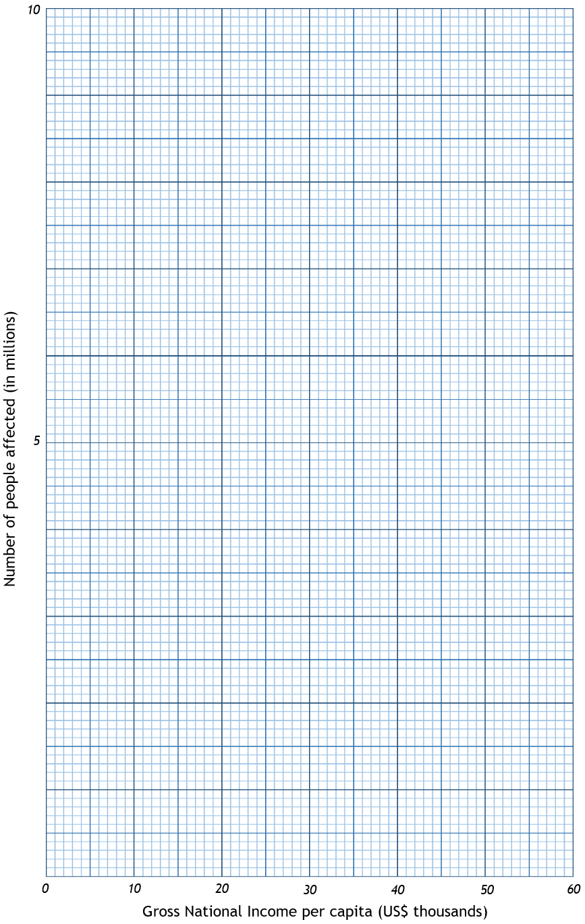
Title:
Visualising the relationship
Describe what the scatter graph shows you.

The relationship can also be described in statistical terms. Below are three ways the data might look once plotted on the scattergraph:
Positive relationship  (As one variable goes up, the other variable goes up) | Negative relationship  (As one variable goes up, the other variable goes down) | No relationship

Use the sketches of the three relationship types above to describe what the scattergraph shows us in statistical terms.

Explain why the scattergraph shows this relationship. Give reasons for the relationship you can see.

THE SPEARMAN’S RANK TEST
We now need to see whether this relationship is statistically significant. To do this, we can conduct a statistical test called the Spearman’s rank test.
This test will provide a numerical value between -1 and +1, which gives an indication of the strength of a possible relationship between the Gross National Income and the number of people affected in the country. A value close to zero suggests the lack of a statistical relationship i.e. a random pattern.
The numerical value also confirms the direction of the relationship. A negative value indicates the possibility of a negative relationship between the two variables and the closer the answer is to -1, the stronger the possibility of a negative relationship and vice versa with a positive result suggesting a positive relationship.
The Spearman rank formula is: $r_{s}=1-\frac{6\sum{d^{2}}}{n^{3}-n}$
$$r_{s}$$ | is the Spearman’s rank test result (this result will always be between -1 and +1).
$$d$$ | is the difference between the rank of the gross national income per capita and the rank of the total number of people affected.
$$n$$ | is the number of pairs of data (In this case is 15).
Method

- Assume there is no relationship between the variables.
- State the null hypothesis – that there is no relationship between the two variables
There is no .
- Complete the ranks in the table. Madagascar has been completed for you. Order each column of data separately. A tied rank takes the average value of the ranks that they would have been. Calculate the differences between the ranks.
Answer A
Answer B
Answer C
Answer D
- Square the individual differences.
- Calculate the sum of the d² column ($\sum{d^{2}})$
- Multiply $\sum{d^{2}}$ by 6 (Answer A)
- Calculate n³ = n x n x n (Answer B) 15 x 15 x 15 in this example
- Subtract n from Answer B to give answer C
- Divide $6\sum{d^{2}}$ by (n³ – n) to give answer D
Calculate 1 – the value of answer D to give you $r_{s}=1-\frac{6\sum{d^{2}}}{n^{3}-n}$

Country | GNI  per capita (in US $) | Rank | Total affected | Rank | d | d²
China | 6,560 |  | 10,355,349
Comoros | 840 | 2 | 9,511
Guatemala | 3,340 |  | 100,000
India | 1,570 | 3 | 920,000
Japan | 46,330 |  | 36,721
Korea Rep | 25,920 |  | 0 | 1.5
Madagascar | 440 | 1 | 1,736 | 4 | -3 | 9
Mexico | 9,940 |  | 69,135
Papua New Guinea | 2,010 |  | 12,346
Philippines | 3,270 |  | 9,980,019
Taiwan (Republic of China) | 6,560 |  | 0 | 1.5
Tonga | 4,490 |  | 4,014 | 5
United States | 53,470 |  | 834 | 3
Vanuatu | 3,130 |  | 20,006
Vietnam | 1,740 | 4 | 48,075

$$\sum{d^{2}}$$ |  | n³ - n
$$6\sum{d^{2}}$$ |  | $$\frac{6\sum{d^{2}}}{n^{3}-n}$$
n³ |  | $$r_{s}=1-\frac{6\sum{d^{2}}}{n^{3}-n}$$

The Spearman rank formula is: $r_{s}=1-\frac{6\sum{d^{2}}}{n^{3}-n}$ $=$

Calculation answer
What is your $r_{s}$value? The result should be between -1 (a perfectly negative correlation) and +1 (a perfectly positive correlation) The nearer to 0, the weaker the correlation. If your number exceeds the range -1 to +1 then there is a mistake in the calculation.

Significance
We need to know how statistically significant this answer is. Is it close enough to either +1 or -1 to be called a correlation?
With 15 pairs of data the critical value, which it needs to exceed, is 0.44. Place your $r_{s}$ result on the line below:
-1 |  | 0 |  |  | +1
Significant |  | Not significant |  |  | Significant
 | -0.44 |  |  | +0.44

Look at the area where your $r_{s}$ result falls. Is your result significant or not significant? Return to your hypothesis and if the result is not significant, you need to accept the null hypothesis you wrote. If it is significant, you need to conclude an alternative hypothesis, that there is a significant relationship between the two variables.

Extension tasks
This exercise has only considered the two variables of wealth of country (as measured by GNI per capita) and level of impact (as measured by the number of people who were affected by the event).
If you were to extend this study, which other variables could you use to investigate a relationship?
How else could you measure the level of impact?
Teaching notes
The calculations for the Spearman rank activity are provided below:
Country | GNI per capita  (in US $) | Rank | Total affected | Rank | d | d²
China | 6,560 | 10.5 | 10,355,349 | 15 | -4.5 | 20.25
Comoros | 840 | 2 | 9,511 | 6 | -4 | 16
Guatemala | 3,340 | 8 | 100,000 | 12 | -4 | 16
India | 1,570 | 3 | 920,000 | 13 | -10 | 100
Japan | 46,330 | 14 | 36,721 | 9 | 5 | 25
Korea Rep | 25,920 | 13 | 0 | 1.5 | 11.5 | 132.25
Madagascar | 440 | 1 | 1,736 | 4 | -3 | 9
Mexico | 9,940 | 12 | 69,135 | 11 | 1 | 1
Papua New Guinea | 2,010 | 5 | 12,346 | 7 | -2 | 4
Philippines | 3,270 | 7 | 9,980,019 | 14 | -7 | 49
Taiwan (Republic of China) | 6,560 | 10.5 | 0 | 1.5 | 9 | 81
Tonga | 4,490 | 9 | 4,014 | 5 | 4 | 16
United States | 53,470 | 15 | 834 | 3 | 12 | 144
Vanuatu | 3,130 | 6 | 20,006 | 8 | -2 | 4
Vietnam | 1,740 | 4 | 48,075 | 10 | -6 | 36

$$\sum{d^{2}}$$ | 653.5 | n³ - n | 3360
$$6\sum{d^{2}}$$ | 3921 | $$\frac{6\sum{d^{2}}}{n^{3}-n}$$ | 1.16
n³ | 3375 | $$r_{s}=1-\frac{6\sum{d^{2}}}{n^{3}-n}$$ | -0.16

