Student task
Annotate the image to show why these types of houses would be vulnerable to a tropical storm.

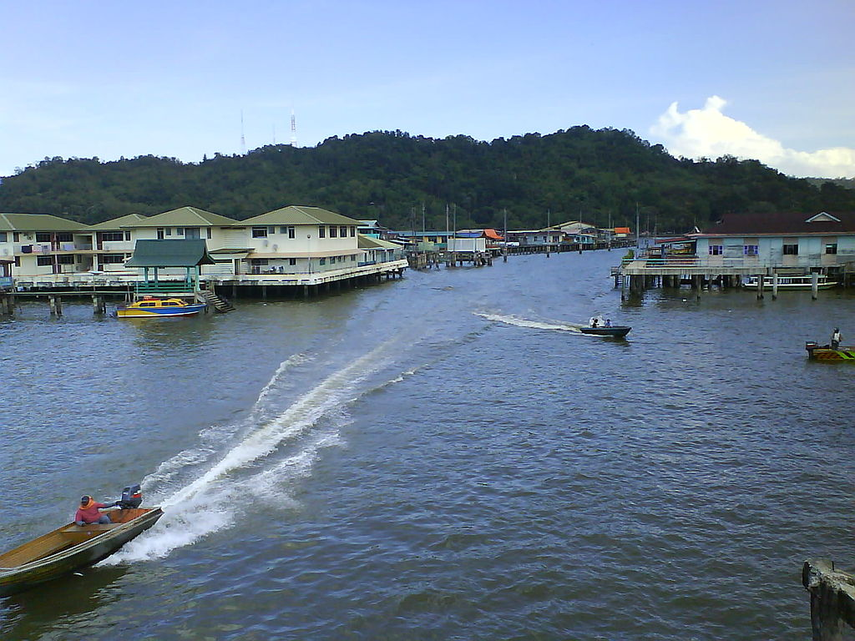

Image place in the public domain by Kurun under the Creative Commons Attribution-ShareAlike 3.0 License

