Antarctica – background context  Small scale tourism to Antarctica began in the 1950s. The first specially designed cruise ship made its first voyage in 1969. Tourist numbers have grown from 9000 in  1992-93 to 33824 in  2010-11. |  | Why do people go to Antarctica? |  | What are the top 3 activities undertaken by tourists visiting Antarctica?  What other activities do people visiting Antarctica do?  Where do the majority of Antarctica’s tourists come from?  Give a reason to explain this.

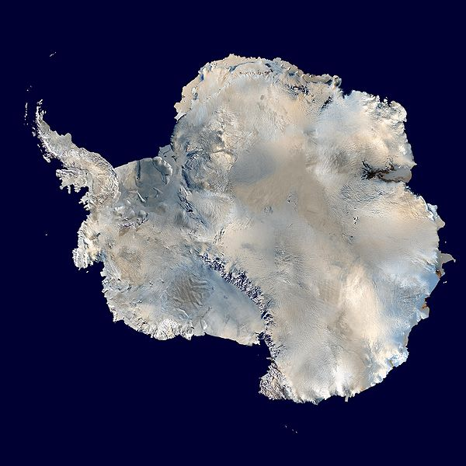 |  | Impacts of tourism in Antarctica.  What are the causes of pollution?  How could pollution impact the food chain?  How could tourists impact penguin populations?  What could tourists visiting Antarctica bring with them and why could this be bad?  What could a positive impact of tourism in Antarctica be? |  | How it tourism being managed?  What is the IAATO?  What does the IAATO Do?  What is the maximum number of passengers allowed on a boat?  List 3 other ways that tourism in Antarctica is restricted (you could get asked a question on management in the exam).

Why has the number of visitors to Antarctica grown?
(Pick out 3 or 4 key reasons)

Impacts of tourism in Antarctica
- Pollution from exhaust fumes and the oil and liquid gas that are emitted from the boats travelling in Antarctica. The increase in tourist numbers means that there is an increasing possibility of larger cruise ships entering the water. Researchers are concerned that if a cruise ship were to strike an iceberg, it could contaminate the water and wildlife with a major oil spill. This could affect and kill rare or endangered species. Even small leaks of oil can affect the krill population, which is the foundation of the Antarctic food chain.
- Whilst there haven’t been any major pollution incidents of loses of life as a result of tourism in Antarctica, there was a very close call in November 2007 when the MV Explorer boat sank. A surface oil slick 1.5km long and covering 2.5km² resulted from the sinking, with further slicks in the days after the sinking.
- There are concerns that tourists may transmit microbes that do not belong in Antarctica, by (either purposefully or accidently) bringing plants or micro-organisms with them that could disturb the natural environment and potentially spread disease.
- There are fears that tourists’ proximity to penguins and seals could disturb their breeding patters and that they may abandon eggs and young as a result. However, there is not yet any evidence of this happening.
- Tourists’ awareness of the fragility of this environment could be increased; as a result, they could become ambassadors for the environment, helping to protect it.

Impacts of tourism in Antarctica
- Pollution from exhaust fumes and the oil and liquid gas that are emitted from the boats travelling in Antarctica. The increase in tourist numbers means that there is an increasing possibility of larger cruise ships entering the water. Researchers are concerned that if a cruise ship were to strike an iceberg, it could contaminate the water and wildlife with a major oil spill. This could affect and kill rare or endangered species. Even small leaks of oil can affect the krill population, which is the foundation of the Antarctic food chain.
- Whilst there haven’t been any major pollution incidents of loses of life as a result of tourism in Antarctica, there was a very close call in November 2007 when the MV Explorer boat sank. A surface oil slick 1.5km long and covering 2.5km² resulted from the sinking, with further slicks in the days after the sinking.
- There are concerns that tourists may transmit microbes that do not belong in Antarctica, by (either purposefully or accidently) bringing plants or micro-organisms with them that could disturb the natural environment and potentially spread disease.
- There are fears that tourists’ proximity to penguins and seals could disturb their breeding patters and that they may abandon eggs and young as a result. However, there is not yet any evidence of this happening.
- Tourists’ awareness of the fragility of this environment could be increased; as a result, they could become ambassadors for the environment, helping to protect it.

Why has the number of visitors to Antarctica grown?
- The media have made people more aware of extreme environments like Antarctica. BBC series such as Frozen Planet for example have made people much more aware of the continent.
- People have more annual leave (holiday) to take from work.
- Air travel is cheaper.
- Holidays can be booked quickly and easily on the internet.
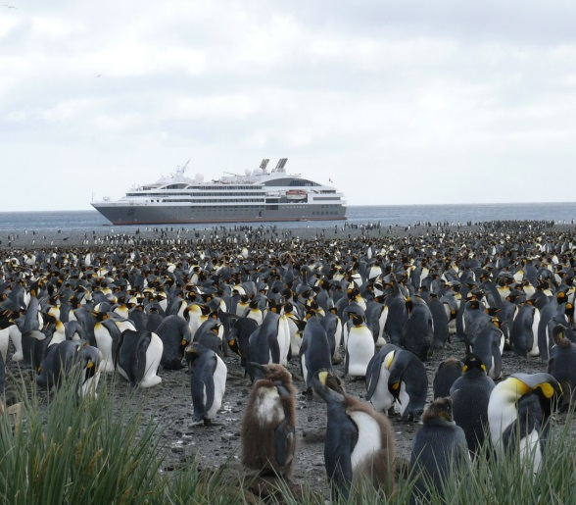
- People are increasingly looking for more adventurous holidays as choice grows.
- People have more money so can afford to travel further.
- Awareness of climate change and environmental issues means tourists want to visit places before they change forever.
- As the ice in Antarctica retreats, it is becoming a more accessible destination for cruise ships.

Why has the number of visitors to Antarctica grown?
- The media have made people more aware of extreme environments like Antarctica. BBC series such as Frozen Planet for example have made people much more aware of the continent.
- People have more annual leave (holiday) to take from work.
- Air travel is cheaper.
- Holidays can be booked quickly and easily on the internet.
- People are increasingly looking for more adventurous holidays as choice grows.
- People have more money so can afford to travel further.
- Awareness of climate change and environmental issues means tourists want to visit places before they change forever.
- As the ice in Antarctica retreats, it is becoming a more accessible destination for cruise ships.

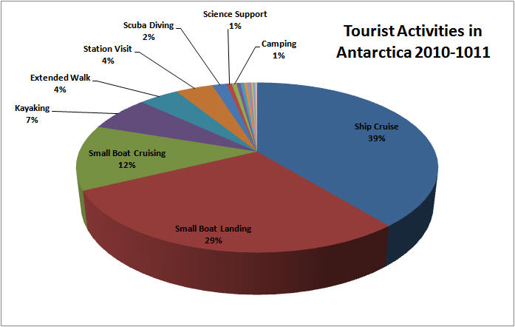
Tourist activities in Antarctica 2010-2011

Where do tourists come from?

Country of origin | Numbers | % of total
USA | 12,629 | 37.4
Australia | 3,220 | 9.5
UK | 2,763 | 8.1
Canada | 2,531 | 7.5
Germany | 2,378 | 7.0
Japan | 936 | 2.8
Netherlands | 889 | 2.6
Others | 8,478 | 25.1
Total | 33,824 | 100

How is tourism being managed in Antarctica?
The IAATO (International Association of Antarctic Tour Operators) is an organisation which rules the companies running holidays to Antarctica and tries to be environmentally friendly. There are about 100 different holiday companies involved. They regulate the boat companies and try to ensure a sustainable future for the continent.
Restrictions on tourism include:
- No boat carrying over 500 passengers can land in Antarctica. There are concerns that larger ships will eventually be allowed and the volume of tourists will go beyond the sustainable limits.
- The tourist industry has to follow the rules of the Antarctic treaty, signed in 1961, where countries agreed to establish Antarctic as a zone free of nuclear testing, free from disposal of radioactive waste and to ensure it was used for scientific purposes only and promoted as a Site of Scientific Interest.
- Visitors are not allowed to visit Sites of Special Scientific Interest which often contain the most vulnerable wildlife e.g. penguin breeding grounds.
- Permits are required to travel in Antarctica.
- The US has its own permit system which applies to all US citizens and makes it unlawful to take native animals or birds from the continent, to enter specially designated areas, to introduce species to the continent or discharge pollutants. Violation of this can lead to a $11,000 fine or one year in prison.

How is tourism being managed in Antarctica?
The IAATO (International Association of Antarctic Tour Operators) is an organisation which rules the companies running holidays to Antarctica and tries to be environmentally friendly. There are about 100 different holiday companies involved. They regulate the boat companies and try to ensure a sustainable future for the continent.
Restrictions on tourism include:
- No boat carrying over 500 passengers can land in Antarctica. There are concerns that larger ships will eventually be allowed and the volume of tourists will go beyond the sustainable limits.
- The tourist industry has to follow the rules of the Antarctic treaty, signed in 1961, where countries agreed to establish Antarctic as a zone free of nuclear testing, free from disposal of radioactive waste and to ensure it was used for scientific purposes only and promoted as a Site of Scientific Interest.
- Visitors are not allowed to visit Sites of Special Scientific Interest which often contain the most vulnerable wildlife e.g. penguin breeding grounds.
- Permits are required to travel in Antarctica.
- The US has its own permit system which applies to all US citizens and makes it unlawful to take native animals or birds from the continent, to enter specially designated areas, to introduce species to the continent or discharge pollutants. Violation of this can lead to a $11,000 fine or one year in prison.
Antarctic bingo: Find someone who can……….

Define extreme tourism. | When did tourism begin in Antarctica? | Explain how pollution in Antarctica could impact the food chain?
Describe two ways tourism is being managed in Antarctica. | Describe the target market for extreme holidays. | What activities do people do when they go to Antarctica?
Give three examples of extreme tourism. | Describe three reasons why people may go to Antarctica on holiday. | Where do the majority of Antarctica’s tourists come from?
Knows approximately how many tourists go to Antarctica each year. | Explain one impact of tourism in Antarctica. | Knows approximately how many tourists go to Antarctica each year.

Teachers Notes
This lesson covers what extreme tourism is, the types of holiday it includes, who goes and a case study. There is an 8 mark exam question; this could be used for a homework task or extension. There is also an Antarctic bingo sheet with questions about extreme tourism. This may provide a useful revision resource or longer plenary on this topic; or could be a starter the following lesson to check recall? Get students to write in answers, not just the name of someone who knows the answer, so that it is actually of some revision value.

- Slide 1: Students to answer stimulus questions in full sentences. It is useful to have something the students can get on with easily on entry to the classroom that doesn’t require discussion. These questions are then discussed later in the lesson so no need for teacher feedback at this stage.
- Slide 2: Introduces learning outcomes for the lesson.
- Slide 3: After a class discussion, students to record the definition of extreme tourism in their exercise books and then to brainstorm examples of extreme environments. As students are working you can quiz the class and get them to share their ideas. Those who work more quickly can be asked to go and share their thoughts with others in the class.
- Slide 4: Goes through the answers to the starter questions. You could get students to go back and extend their answers in a different coloured pen, adding in any missed detail. These questions are a great opportunity to randomly question students in the class, stretching your most able by asking them deeper questions.
- Slide 5: Review learning outcomes – opportunity for students to ask any questions.
- Slide 6: Introduce Antarctica as the case study. One click on the image will open a video (very short) that contains wow images of Antarctica. You don’t have to discuss with students why you would visit but this should just provide them with stimulus.
- Slide 7: Introduce information hunt. You can do this in various ways – by having info cards at four different stations on tables or walls around the room or randomly distributing the cards and then students have to put their hand up when finished, find a peer who also has their hand up to signal they are finished, hi 5 and swap cards. Always print some spare copies of cards as some take longer to make notes than others. The students can make their own notes (for more able students) or use the worksheet which makes extracting the key points much quicker.
- Slide 8: Contains key points from the worksheet/students notes. Students can peer or self-mark and add to their notes/worksheet if necessary.
- Slide 9: Could be an extension/homework task if students finish note taking early.
- Slide 10: Slide talks through what students would need to include for a Level 1 (1-3 marks), 2 (4-6 marks) or 3 (7-8 marks) answer.
- Slide 11: A simple confidence table that students can complete at the end of the lesson visually with a thumb up to you or one you can print off and stick in their books. It can be nice for students to look back when revising and see what they felt confident about at time of learning.

