FACT: A growing percentage of the world’s population lives in urban areas.
What do we mean by an ‘urban area’? |  | How much (in percentage terms) are we thinking about?
Where do you think this photograph was taken? | 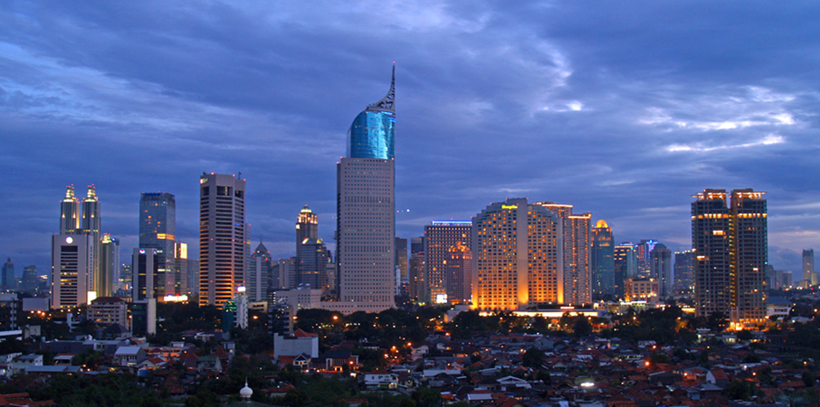  Source: © The Diary of a Hotel Addict 2008 flic.kr/p/4vAyAe |  | Why is the percentage of the world’s urban population growing?
Who might be attracted to cities such as this? |  | Which urban areas are growing the fastest?

Teaching notes and suggested answers

- What do we mean by an urban area?
An urban area implies towns and cities. You could ask your students what defines an urban area.

- How much (in percentage terms) are we thinking about?
Approximately one third of the world’s population (34%) lived in towns and cities in 1960. This had risen to approximately half (54%) by 2014 and by 2050, it is expected that around 66% of the world’s population will be living in urban areas.
It is important to distinguish between the percentage of the world’s urban population and the world’s urban population in absolute numbers. Currently, the percentage of the world’s urban population is greatest in the countries of the developed world, e.g. the UK at 85% in 2015 but in absolute numbers, the urban population growth is concentrated in the less developed regions of the world. However, by 2017, it is estimated that even in less developed countries numerically, a majority of people will be living in urban areas.

- Where do you think this photograph was taken?
Jakarta, Indonesia in 2008.

- Why is the percentage of the world’s urban population growing?
This is due to a combination of the natural increase in population and push and pull factors. The latter encourage rural to urban migration. Students could be asked to list push and pull factors.

- Who might be attracted to cities such as this?
Young people especially young males and later their families. Students could be asked to consider this answer in relation to the previous answer.

- Which urban areas are growing the fastest?
Presently, the world’s fastest growing cities are to be found largely in Asia and Africa e.g. Suzhou, China; Guangzhou, China; Surat, India; Luanda, Angola; Kinshasa, Dem. Rep. of Congo; Lagos, Nigeria; Beijing, China; Hangzhou, China; Quanzhou, China and Bangalore, India.

