This activity will help you to:

- locate Mumbai.
- appreciate its importance regionally, nationally and internationally.
- understand why it has grown so rapidly.

Student tasks

- On the India in the world map outline, shade and label the country of India.

- On The states of India outline map of India, mark on the following:
- the city of Mumbai
- the capital city, New Delhi
- the Arabian Sea
- the Bay of Bengal
- the Indian Ocean
- the state of Maharashtra

- On the more detailed map of Mumbai city, identify the following:
- the Sanjay Gandhi National Park
- the centre of Mumbai
- Navi Mumbai
- the slum area of Dharavi.

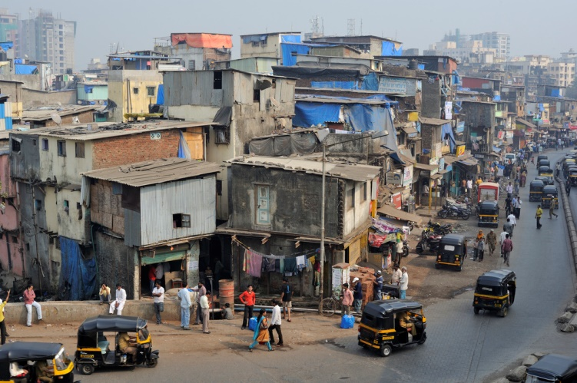

The edge of Dharvai in Mumbai
Image used courtesy of M M Padmanaba01, 2010 under a 2.0 Generic (CC by SA 2.0 license. flickr.com/photos/43423301@N07/5842973175/

India in the world

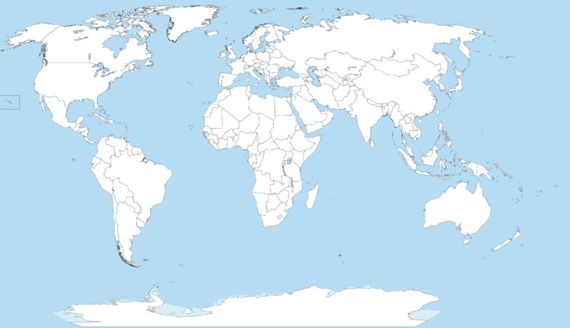
Image in public domain under Creative Commons Attribution-Share Alike 3.0 Unported license.2014, courtesy of Wikepedia commons.wikimedia.org/wiki/File:A_large_blank_world_map_with_oceans_marked_in_blue.PNG

The states of India

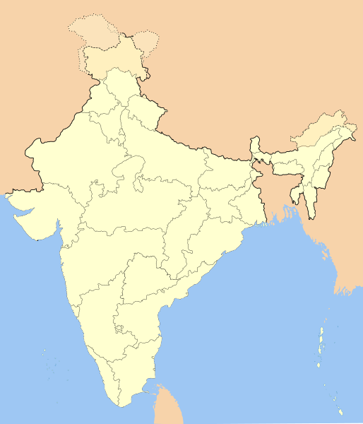

Image in public domain under Creative Commons Attribution-Share Alike 3.0 Unported license.2016, courtesy of Wikepedia
en.wikipedia.org/wiki/File:India-locator-map-blank.svg

The states of India

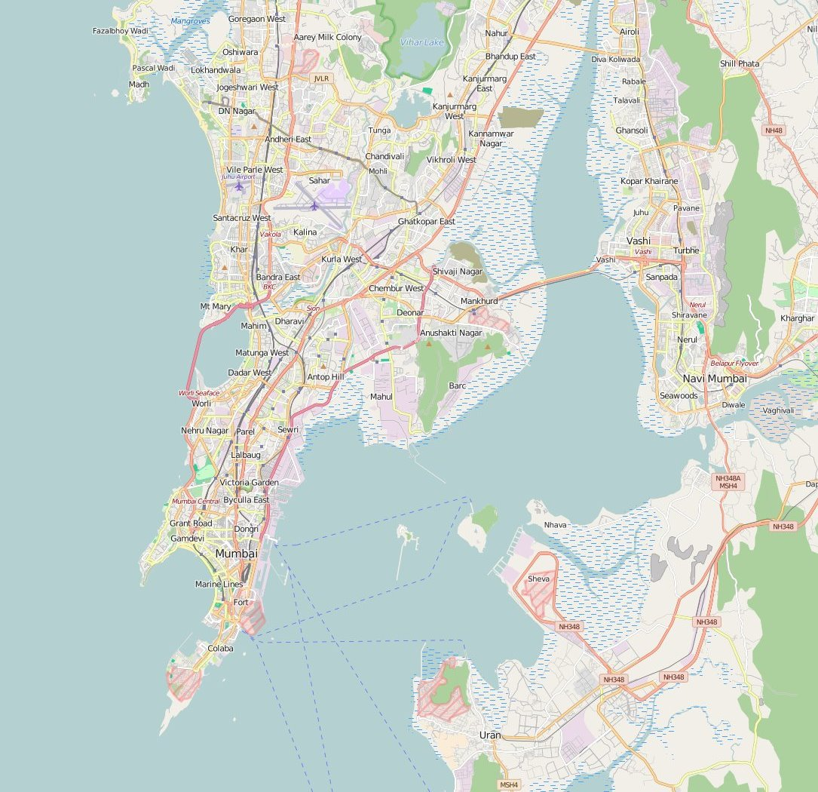
Map used courtesy of OpenStreetMap under the Creative Commons Attribution-ShareAlike 2.0 licence. openstreetmap.org/#map=12/18.9917/72.8479

- Use the Internet to research Mumbai’s importance as a regional, national and international centre and its growth over time and space.

- Insert details into the relevant boxes below. A few points have been added to get you started.

Growth
Largely due to natural increase and rural-urban migration.
Population has nearly doubled since 1991, from 12.5 million to over 21 million people today (estimated figure for the city and its metropolitan area in 2015).
Started life as a series of fishing villages, became a port, with growth concentrated on the peninsular, and is now a megacity.
The Malad-Dahisar region in the west and Cembur-Govandi region in the east have grown the fastest.
The north is becoming more populated, whilst the south is now less populated.

Importance Nationally
India’s financial and commercial centre.
India’s principal port.

Importance Regionally
The capital city of the Indian state of Maharashtra.

