A slum in Jakarta Indonesia

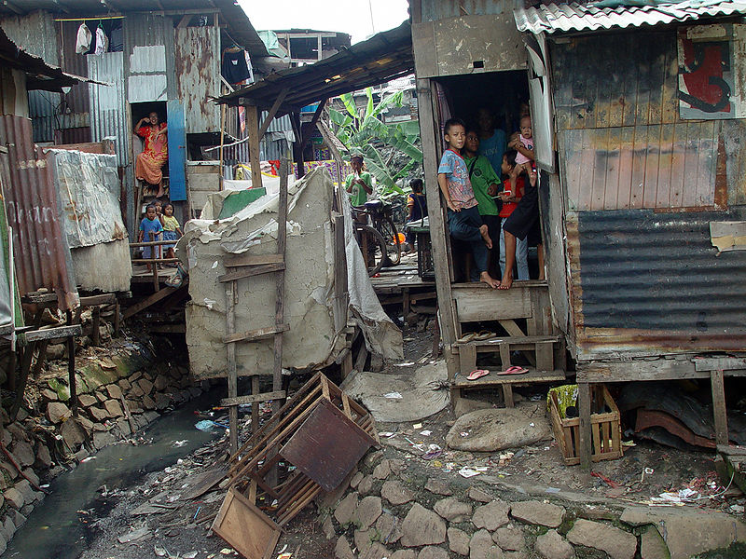
See
Touch
Hear
Feel (emotions)
Smell
Taste

Image used courtesy of©JonathanMcIntosh2004/commons.wikimedia.org/wiki/File:Jakarta_slumlife31.JPG

Extension task

The image was taken in 2004. How do you think this slum/shanty town will have changed since then?

