S.A.T.O.

This image shows informal employment in a LIC city. The man may have migrated from the countryside in search of a better life.

In geography useful information can usually be obtained from studying photographs like this. One helpful method is to answer SATO questions.

Senses

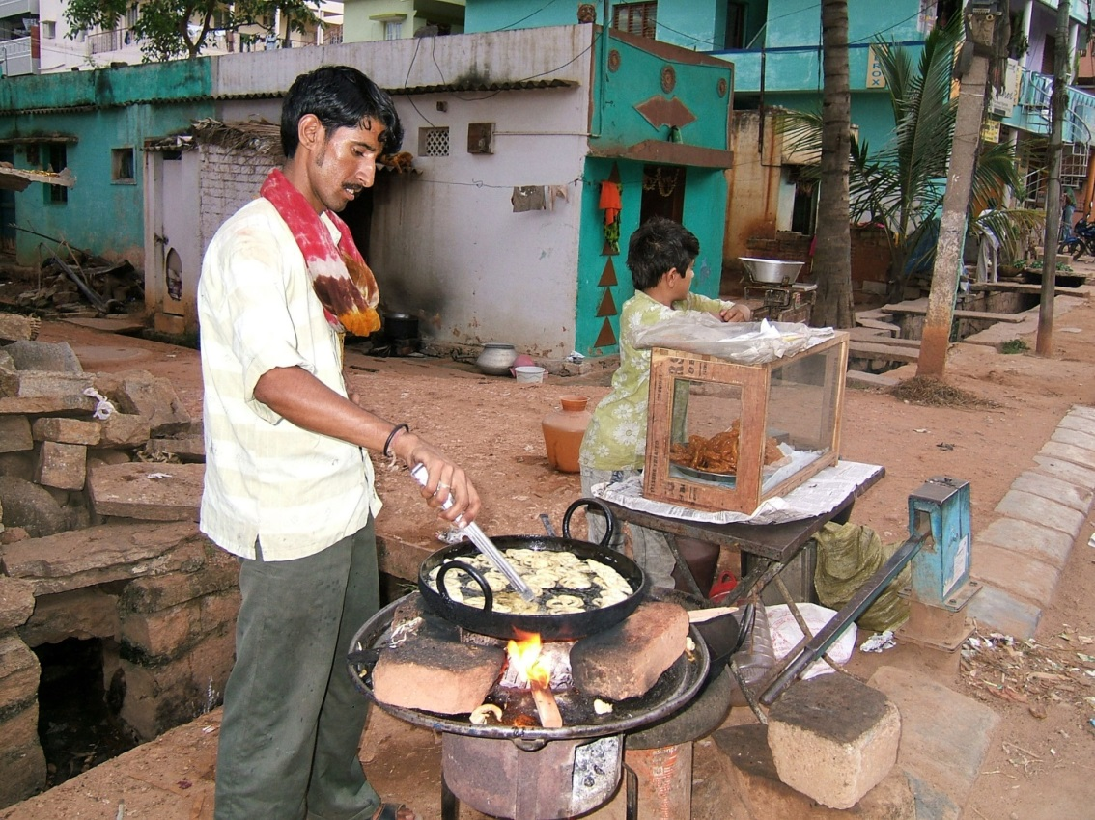
- What can you see?
- What could you hear if you were there?
- What could you smell if you were there?

Action

- What do you think is happening in the photograph?
- Why was it happening?
- What could be going on to the left and right of the scene in the photograph?

Time

- What do you think happened immediately before this photograph was taken?
- What do you think might happen next?
- How do you think the scene in the photograph has changed since the photograph was taken in 2007?
©Shankar.s.2007 https://flic.kr/p/cCTHKY
Overall

- What does this photograph tell us, e.g. about people and place/location?

