Introduction

Population density is the number of people living in a particular area, e.g. the population density of the UK is approximately 259 people per km². Some areas will be much higher than others, e.g. cities such as London, Portsmouth and Liverpool. The population density in a city is always very high, e.g. in 2011, Greater London had a population density of approximately 5,200 people per km².

Student tasks

Use the table on the next page.

- Which region of the UK had the highest population density in 2011?

- Which region of the UK had the lowest population density in 2011?

- What was the average density for all of the Uk in 2011?

- Which region of the UK was nearest the average population density in 2011?

- The average density in Scotland was approximately 67 people per km². Name an area or place in Scotland that has a higher population density.

- Construct a bar graph of the population densities of the UK in 2011. Use a vertical scale of 1 cm to 1,000 people per km².

Region | Population (2011) | Population density (2011)
England | 53,012,456 | 406.55/km²
- South East  - Greater London  - North West  - East  - West Midlands  - South West  - Yorkshire and Humber  - East Midlands  - North East | 8,634,750  8,173,941  7,052,177  5,846,965  5,601,847  5,288,935  5,283,733  4,533,222  2,596,886 | 452.20/km²  5199.71/km²  497.86/km²  305.80/km²  430.00/km²  221.95/km²  342.65/km²  290.09/km²  302.24/km²
Scotland | 5,295,000 | 67.22/km²
Wales | 3,063,456 | 147.43/km²
Northern Ireland | 1,810,863 | 130.81/km²
United Kingdom | 63,181,775 | 259.16/km²

Data adapted from Office of National Statistics, under Open Government Licence v3.0
ons.gov.uk/peoplepopulationandcommunity/populationandmigration

Extension task

Use the table of population densities of the UK in 2011 to construct a bar graph of regional population densisties on the map on the next page:

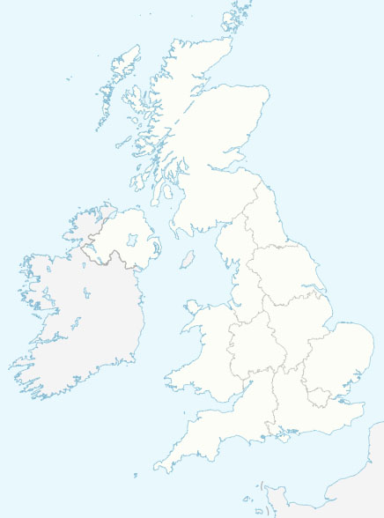
Map used courtesy of NordNordWest, 2008
Creative Commons Attribution-Share Alike 3.0 Unported license.

