Introduciton

The satellite image below shows most of Great Britain as it appeared on the night of 27 March, 2012. The areas of white show the major centres of population.
Student tasks

- Which country of the United Kingdom, England, Wales, Scotland and Northern Ireland has the largest number of bright lights at night?
- Which country of the British Isles has the lowest number of bright lights at night?
- What are the lights in the northeast corner of the satellite image?
- Use an atlas to name the ten largest cities on the satellite image below:

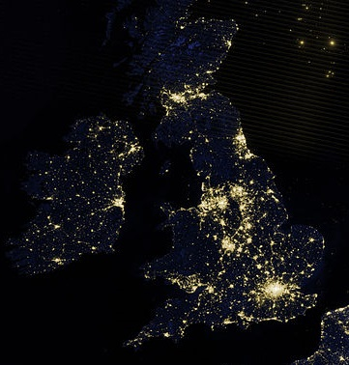
Map used courtesy of the NASA Earth Observatory the Creative Commons Attribution 2.0 Generic license. commons.wikimedia.org/wiki/File:Northwestern_Europe_at_night_by_VIIRS.jpg

