Introduction

The Romans established the first settlement of Londinium on the banks of the River Thames. Today, London is the largest city in England and the United Kingdom and has a worldwide influence. Within the city there are a a diverse range of peoples and cultures, with more than 300 languages spoken.
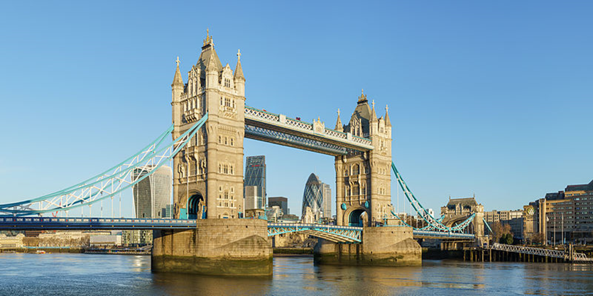
© User:Colin / Wikimedia Commons / CC BY-SA 4.0

Your task is to produce a detailed case study of London as an urban settlement.

Student tasks

- Find a map to show the location of the city in relation to other countries throughout the world.

- Find a map to show the location of the city within the UK.

- Include one or more images that is/are representative of London.

- Explain the important of the city globally. Do not forget to give sources for your information.

- Explain the importance of the city nationally. Have you given sources?

- Urban change in London has created many social opportunities. How has migration affected London? What cultural, recreation and entertainment opportunities are there in London?

- Urban change in London has created many economic opportunities. List some of the economic opportunities in London.

- What is the importance of the integrated transport systems in London?

- London has created many environmental opportunities, e.g. urban greening. Explain the importance of green spaces within London.

- Urban change in London has also created social and economic challenges. Describe the challenges of urban deprivation, inequalities in housing, education, health and employment.

- Urban change in London has also created environmental challenges. What is urban dereliction? What are brownfield and greenfield sites? What are the challenges of waste disposal in London?

- What are the impacts of national and international migration on the growth and character of the city?

- What are the impact of urban sprawl on the rural–urban fringe of London?

- What are commuter settlements?

Name:
Date:

Self-assessment

I think that I have achieved marks.

Reasons:

Peer assessment

I think that achieved marks.

Reasons:

Suggested area(s) for improvement

Teacher assessment

I think that has achieved marks.

Reasons:

Suggested mark scheme

Marks | Description
1 - 3 | - Has included a suitable map to show the location of the city in relation to other countries throughout the world, but a caption is missing.  - Has ‘zoomed in’ and included a map to show the location of the city within the UK, but no caption is visible.  - Has included an image that is fairly representative of the city.  - Has shown some awareness of copyright restrictions , but the source/s of the inserted material, e.g. maps and image, has not been recorded.  - Has begun to explain why the city is important nationally.  - Has begun to explain why the city is important globally.  - Has briefly outlined the impact of urban sprawl on the rural-urban fringe and the growth of commuter settlements, but no named examples have been given.  - Has listed a couple of social, economic and environmental opportunities relating to urban change.  - Has listed a couple of social, economic and environmental challenges relating to urban change.  - Has identified a few of the impacts of both national and international migration on the growth and character of the city, but no statistical evidence has been mentioned.  - Has shown limited use of initiative, with findings presented in a somewhat disorganised manner.  - Has conducted a degree of independent research and utilised a few different sources in order to gain the required information.

4 - 6 | - Has included a suitable map to show the location of the city in relation to other countries throughout the world, but little or no caption has been added.  - Has ‘zoomed in’ and included a map to show the location of the city within the UK, but the accompanying caption is either brief or omitted entirely.  - Has included an image that is representative of the city.  - Has considered copyright implications to some degree and attempted to identify the source/s of much of the inserted material, e.g. maps and image.  - Has given some reasons as to why the city is important nationally.  - Has given some reasons as to why the city is important globally.  - Has identified the impacts of both national and international migration on the growth and character of the city, although statistical evidence is limited.  - Has listed some social, economic and environmental opportunities relating to urban change.  - Has listed some social, economic and environmental challenges relating to urban change.  - Has discussed the impact of urban sprawl on the rural-urban fringe and the growth of commuter settlements, with just one or two example/s named.  - Has shown some use of initiative and presented findings in an appropriate manner.  - Has conducted independent research and utilised several sources in order to gain the required information.

7 - 10 | - Has included a suitable map to show the location of the city in relation to other countries throughout the world, along with an appropriate caption.  - Has ‘zoomed in’ and included a map to show the location of the city within the UK, which is accompanied by a brief caption.  - Has included at least one image that is truly representative of the city.  - Has clearly identified the source(s) of all inserted material, e.g. maps and images.  - Has explained in detail why the city is important nationally.  - Has explained in detail why the city is important globally.  - Has identified the impacts of both national and international migration on the growth and character of the city, incorporating relevant statistics.  - Has listed many social, economic and environmental opportunities relating to urban change.  - Has listed many social, economic and environmental challenges relating to urban change.  - Has discussed the impact of urban sprawl on the rural-urban fringe and the growth of commuter settlements, naming several examples.  - Has shown use of initiative and presented findings in an imaginative and effective manner.  - Has conducted independent research and utilised a number of sources in order to gain the required information.

Useful webpages

- google.co.uk/maps
- bing.com/mapspreview
- search.creativecommons.org/
- data.london.gov.uk/census/
- data.london.gov.uk/demography/
- files.datapress.com/london/dataset/population-change-1939-2015/historical%20population%201939-2015.pdf
- youtube.com/watch?v=oAFQ1W1JZ0w
- theguardian.com/cities/2014/may/15/the-evolution-of-london-the-citys-near-2000-year-history-mapped
- bbc.co.uk/news/uk-england-london-31056626

