Introduction

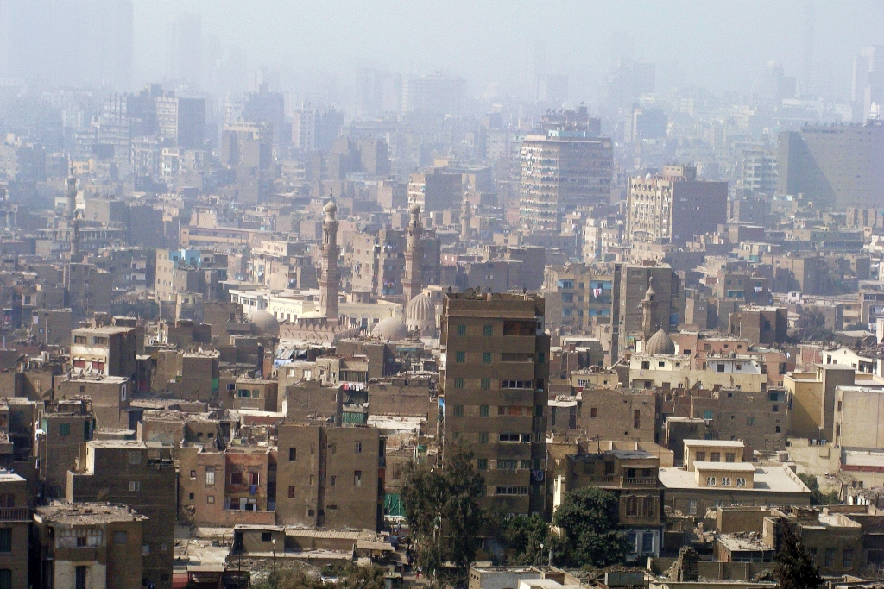
In 2007, Cairo’s air was ranked as the worst in the world for pollution by particulates by the World Bank. Particulates are tiny fragments of soot or dust that are most damaging to human lungs.
Cairo in Smog, Silar, commons.wikimedia.org/wiki/File:0021_Cairo_in_smog,_2010.JPG, 2010, CC BY-SA 3.0

Student tasks

- Write five words to describe Cairo in the image above.

- What title would you give this image?

- What do you think? Answer the following questions:

- Is there affordable housing for everyone?
- Is there enough investment in the city centre?
- Are the homes in Cairo energy efficient?
- Do people walk, cycle or use public transport rather than cars in Cairo?
- Is there a strong sense of community?
- Do they use renewable energy in Cairo?
- How could Cairo be more sustainable?

