Introduction

Curitiba is the capital and largest city in the state of Paraná in southeast Brazil. The city witnessed a very large increase in its population from the middle of the 20th century and was often gridlocked with traffic. Residents felt that the city was under attack.

In 1971, Jaime Learner was elected mayor of the city and said that a combination of “Mobility, sustainability, and identity” was the answer. He wanted Curitiba to be great place to live and approached the problem with a radical plan involving public transport. Today, Curitiba is considered one of the world's most successful examples of urban planning.

Location and facts – Curitiba, Brazil
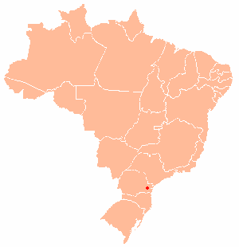
Curitiba
BRAZIL

- Curitiba is the capital Paraná state in southeast Brazil, approximately 1 000km from Rio de Janeiro.

- The 2010 census recorded the population of Curitiba at approximately 2.5 million people.

- Curitiba is the eighth most populous city in Brazil.

- Between 1950 and 1990, the population increased rapidly, from 300 000 to 2.1 million.

Curitaba, NordNordWest, 2013 wikipedia.org/wiki/Curitiba CC BY-SA 3.0

Student tasks

- Watch the following video clip, youtube.com/watch?v=hRD3l3rlMpo which describes sustainability schemes in Curitiba, Brazil. Sustainability has many different aspects, but here, you should focus on sustainability linked to transport. Note down any relevant points that may help you to answer the questions below later on.

- Answer the questions:

- How has the road system been made more efficient? Draw a sketch of the new transport plan.

- How many people benefit from new system of transportation?

- How is public transport in Curitiba funded?

- How have both the buses and boarding tubes been modified? How is this a sustainable strategy?

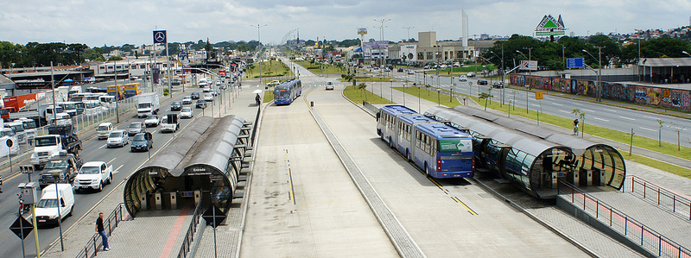
- Add labels to the image of a street scene in Curitiba, to highlight key aspects of its transport sustainability plan.

©mariordo59, 2011, flic.kr/p/dSEKqN

