- Study Figure 1 which shows average physical exposure to tropical storms.
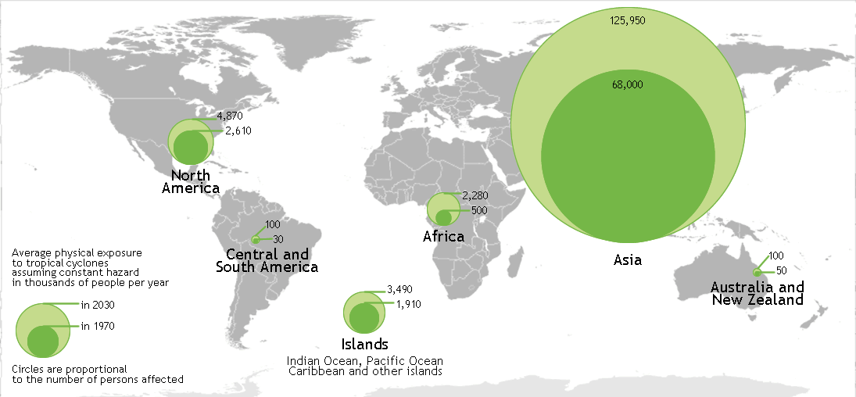
Figure 1
Complete the following paragraph. Use figure 1.
The highest number of people exposed to tropical storms is within the continent of ________________. The Islands areas, including islands in the Indian Ocean, Pacific Ocean etc. in 1970, had ________________ thousand people per year exposed to tropical storms.
[2 marks]

- Give one way that climate change may affect tropical storms in the future.

[1 mark]

- Study figure 2a and 2b, which show some immediate responses to a tropical storm.
Figure 2a Figure 2b
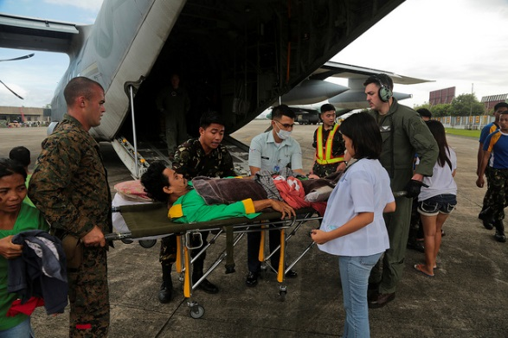
Using figures 2a and 2b only, describe two characteristics of the immediate short-term response to the tropical storm.
Characteristic one:

Characteristic two:

2 x 2 marks [4 marks]
- Describe the primary and secondary effects of a tropical storm.

[9 marks] + 3SPaG

END OF QUESTIONS

Image credits:
Page 1: Figure 1: Map created from image in the public domain http://commons.wikimedia.org/wiki/File:BlankMap-World6-Equirectangular.svg. The file is made available under the Creative Commons CC0 1.0 Universal Public Domain Dedication.
Page 2: Figure 2a: © Marion Doss 2007 https://flic.kr/p/5Enrfz
Figure 2b: © DVIDSHUB 2013 https://flic.kr/p/hvLbqA

