Hurricanes are the most violent storms on the planet and cause tremendous destruction. They are also called tropical storms, typhoons or cyclones, depending on their geographical location, e.g. tropical storms which form over the western Pacific Ocean are called typhoons.
Student tasks
- Use an atlas to label the world map below with:
- the Atlantic and Pacific Oceans
- the Tropics of Cancer and Capricorn
- five countries affected by tropical storms i.e. hurricanes, cyclones or typhoons.
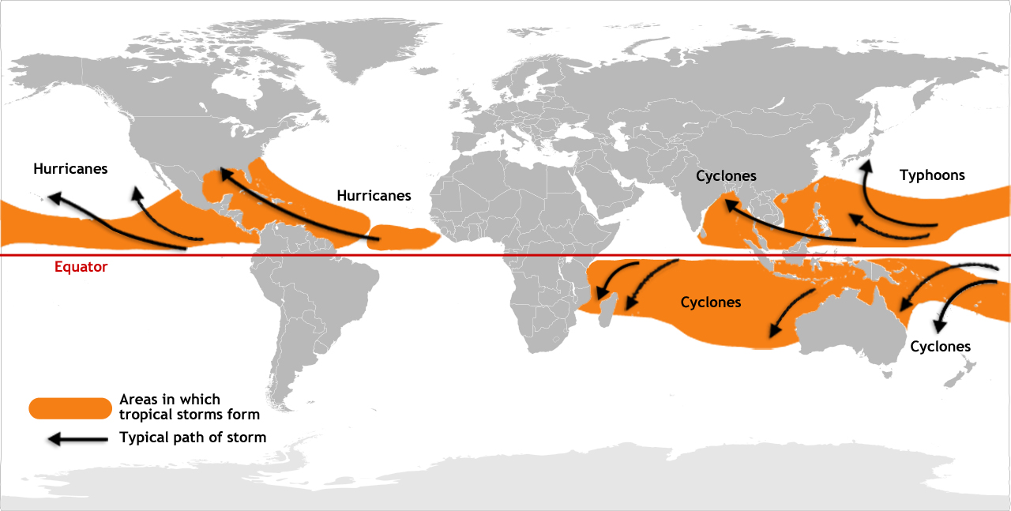
- Using the map on the previous page, write a sentence to describe the location of the areas where tropical storms form.

- The image below shows a tropical storm approaching an area of land.

- Use an atlas to label two countries on the image.
- Label the eye of the hurricane.
- Draw an arrow to show the direction that the tropical storm is moving.

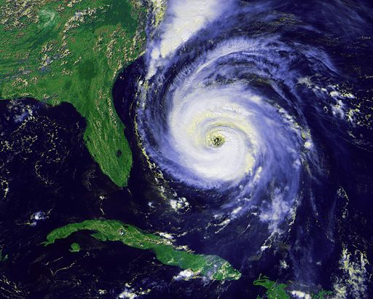
By NOAA / National Climatic Data Center [Public domain], via Wikimedia Commons

