- Pyramid is typical of a country such as Kenya or Somalia. | - Narrower at the base which means birth rates are lower.
- LIC | - Wide at the base which means there are a large proportion of young people in the country.
- Wide at the top because there is longer life expectancy. | - The pyramid narrows as the ages increase due to higher death rate
- Narrow at the top which shows there is a small proportion of elderly people. | - Wider in the middle which means that people are living longer, less infant mortality.
- HIC | - This pyramid is typical of a country such as Italy and the UK.

To be able to identify key features of a population pyramids. Answer these questions, by circling the correct answer. :
Population pyramid 1  (your pyramid)  It has a high birth rate / low birth rate.  It has a high death rate / low death rate .  Which section of the population has most people?  It is a HIC / LIC ? |  |  |  | In pairs, look at each other’s pyramids and complete the sentences and a sketch of the other pyramid  Population pyramid 2  It has a high birth rate / low birth rate .  It has a high death rate / low death rate .  Which section of the population has most people?  It is a HIC / LIC?
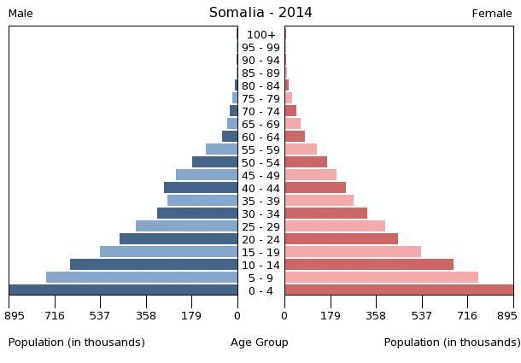  Pyramid 1  Pyramid 1 |  | To be able to explain population pyramids and compare LICs and HICs.  Explain the changes that have happened in your pyramid using the PEE Chain to structure your answer.  Prompt words: health care, education, emancipation of women, agriculture family planning, contraception.

Pyramid 2

To be able to identify key features of a population pyramids. Answer these questions, by circling the correct answer. :
Population pyramid 2  (your pyramid)  It has a high birth rate / low birth rate.  It has a high death rate / low death rate .  Which section of the population has most people?  It is a HIC / LIC ? |  |  |  | In pairs, look at each other’s pyramids and complete the sentences and a sketch of the other pyramid  Population pyramid 1  It has a high birth rate / low birth rate .  It has a high death rate / low death rate .  Which section of the population has most people?  It is a HIC / LIC?
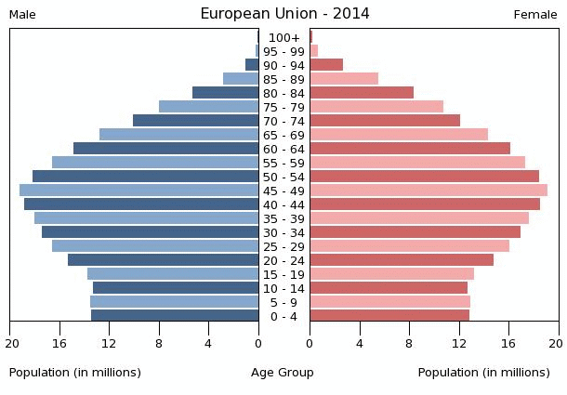  Pyramid 2 |  | To be able to explain population pyramids and compare LICs and HICs.  Explain the changes that have happened in your pyramid using the PEE Chain to structure your answer.  Prompt words: health care, education, emancipation of women, agriculture family planning, contraception.

Pyramid 1

Homework
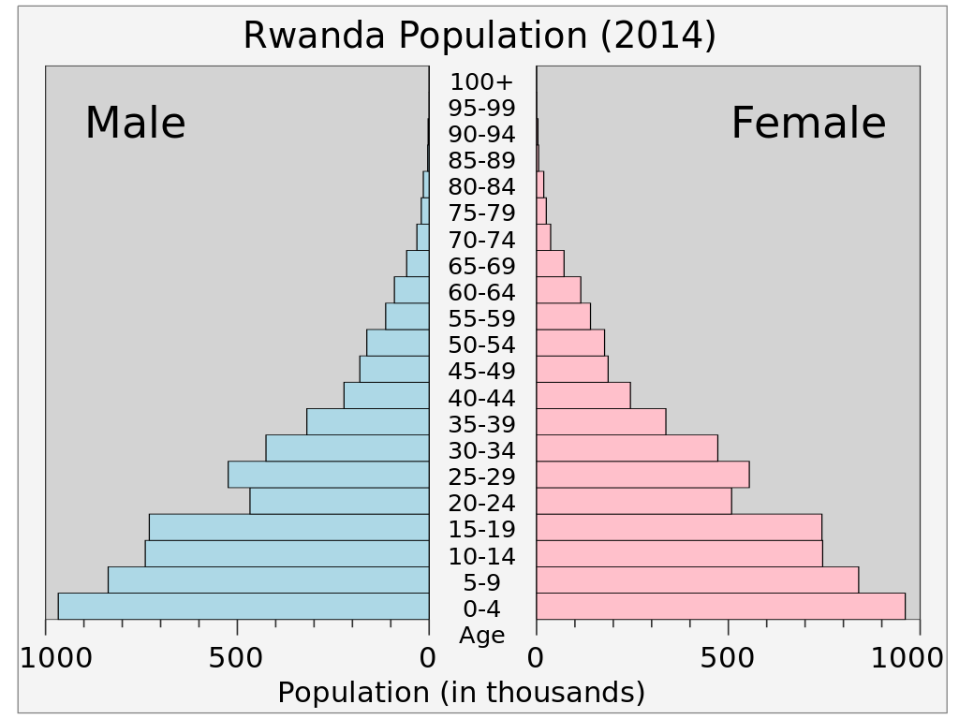 | 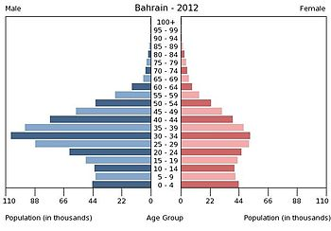

- Both of these pyramids have anomalies. Why do you think this is?
- Research both countries:
- Why is there suddenly a drop in the overall population in Rwanda?
- Why there are significantly more males in Bahrain than females?
- Can you think of four other factors that may affect population?

