Brandt Report
The Brandt Report was written by the Independent Commission, first chaired by Willy Brandt (the former German Chancellor) in 1980, to review international development issues.

The report identified the Brandt Line, a north south divide between the extremely wealthy HICs and the poorer LICs.

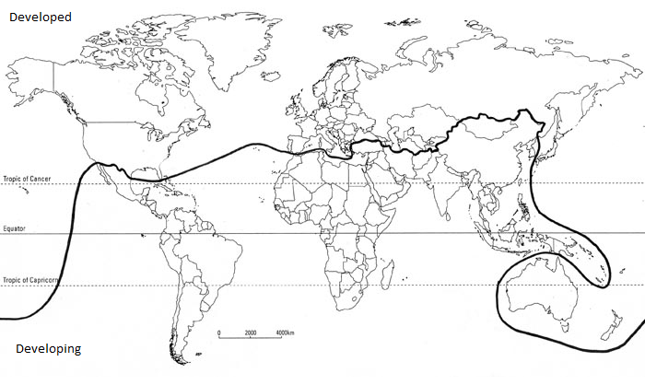
Map used courtesy of ovan.gec, 2015 under the Creative Commons Attribution-Share Alike 4.0 International license.commons.wikimedia.org/wiki/File:The_Brandt_Line.png

Student tasks
The rush to the towns has created the same kind of misery as existed in the 19th century cities of Europe and America. But industrialisation in those days was labour-intensive, so that the cities grew as the jobs expanded.
The migration in today’s developing world is often due to the lack of opportunity in the countryside – it is ‘rural push’ as much as ‘urban pull’. The consequences of high birth rates and rapid migration are all too visible in many cities of the Third World (now referred to as LICs or LICs), with abysmal living conditions and very high unemployment or underemployment.
The strains on families, whose members are often separated, are very heavy. In Sao Paulo in Brazil, the population was growing at around 6-7 per cent annually in the late sixties and early seventies, in such appalling conditions that infant mortality was actually increasing.
The fact that people still migrate to these cities only underlines the desperate situation which they have left behind.
- Read the extract from the Brandt Report below.

- What does the Brandt Report identify as being the two main causes of urbanisation?

- What does the Brandt Report identify as one cause of urban growth?

- Complete the card sort to match the correct term to the appropriate definitions.

Term | Definition
natural increase | The expansion of towns and cities so that they cover more land, as well as gaining large populations.
birth rate | The movement of people from the countryside to towns and cities where they wish to live permanently.
death rate | Reasons why people are encouraged to leave rural areas.
urbanisation | The average number of deaths of children under one year of age per 1000 live births.
unemployment | Employed at work, yet does not make use of or acknowledge one's full ability, training or such like.
underemployment | The number of deaths per 1000 people per year.
push factors | Reasons why people are attracted to urban areas.
rural-urban migration | The growth in population resulting in an excess of births over deaths.
pull factors | The increase in the proportion of people living in towns and cities.
infant mortality | The number of live births per 1000 people per year.
urban growth | The state of not having a job.

Teaching notes
- The Brandt Report identifies the main cause of urbanisation as push and pull factors encouraging rural-urban migration. However, the high birth rate in the urban areas will also contribute to a higher urbanisation percentage.
- The Brandt Report identifies a cause of urban growth as natural increase with birth rates of 6-7 per cent annually in the late sixties and early seventies.
- Card sort:
Term | Definition
natural increase | The growth in population resulting in an excess of births over deaths.
birth rate | The number of live births per 1000 people per year.
death rate | The number of deaths per 1000 people per year.
urbanisation | The increase in the proportion of people living in towns and cities.
unemployment | The state of not having a job.
underemployment | Employed at work, yet does not make use of or acknowledge one's full ability, training or such like.
push factors | Reasons why people are encouraged to leave rural areas.
rural-urban migration | The movement of people from the countryside to towns and cities where they wish to live permanently.
pull factors | Reasons why people are attracted to urban areas.
infant mortality | The average number of deaths of children under one year of age per 1000 live births.
urban growth | The expansion of towns and cities so that they cover more land, as well as gaining large populations.

