A slum in Jarkarta Indonesia

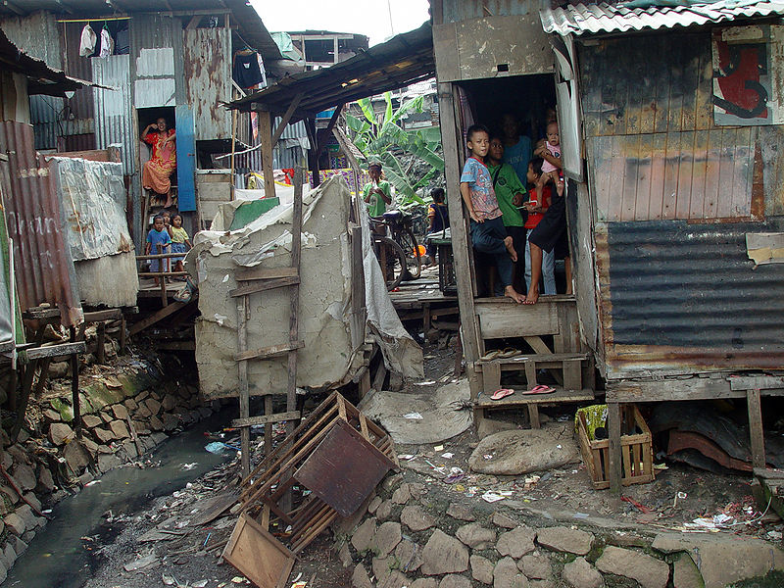

Image used courtesy of ©JonathanMcIntosh2004/commons.wikimedia.org/wiki/File:Jakarta_slumlife31.JPG

My top ten wishes are:

