S.A.T.O.

In urban geography useful information can always be obtained from studying photographs. One method is to answer SATO questions.

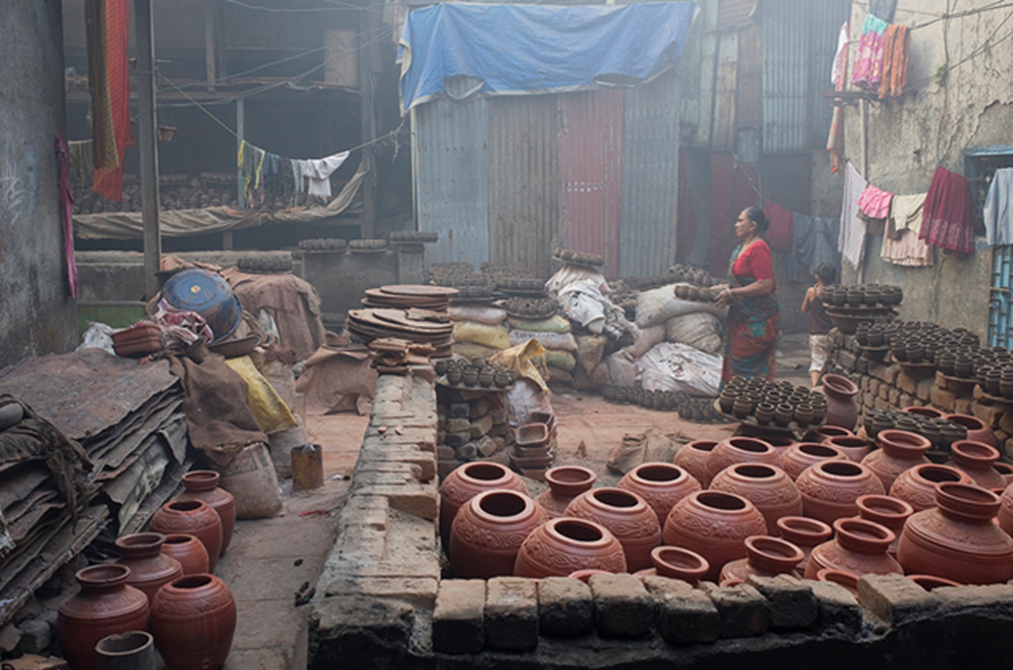
Senses

- What can you see?
- What could you hear if you were there?
- What could you smell if you were there?

Action

- What do you think is happening in the photograph?
- What could be happening to the left and right of the scene in the photograph?

Time

- What do you think happened immediately before this photograph was taken?
- What do you think might happen next?
- How do you think the scene in the photograph has changed since the photograph was taken?
©MM2010https://flic.kr/p/9aDcRU
Overall

- What does this photograph tell us, e.g. about people and place/location?

