Introduction

Dharavi in Mumbai is one of the largest slums in the world. It was made famous by the film, Slumdog Millionaire. The slum has a population of between 700,000 and 1 million people and currently covers an area of approximately 200 hectares or 2km2.

Dharavi dates back to 1882, when factories and residents were moved out of the city centre to what was then a mangrove swamp. Since then it has grown considerably due to migration from the surrounding poor rural areas into Mumbai.

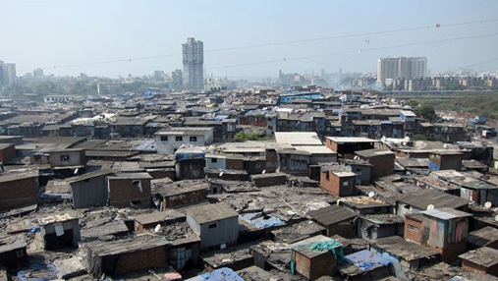
The very high population density and poor sanitation in Dharavi has resulted in the easy spread of many diseases.

Since 1997, there have been several plans to redevelop Dharavi. The slum is next to three railway lines and several major roads making it easily accessible to nearby Mumbai city centre and the rest of India.

Private developers are keen to develop the area. In 2010, it was estimated the redevelopment would cost at least US$2.2 billion.

©TheForumofYoungGlobalLeaders2011flic.kr/p/aW97tx

Student tasks

- What is the population density of Dharavi?

- What diseases might spread easily in Dharavi?

- Listen to the BBC radio programme, Crossing Continents, India - The Real Slumdog Story at:

bbc.co.uk/programmes/b00cyl87

This explains a controversial plan to provide the answer Dharavi’s problems.

- Read the two pargraphs below:

The latest urban redevelopment plan proposed for the Dharavi area is to to raze it to the ground and to construct 2,800,000 square metres of housing, schools, parks and roads to serve the families residing in the area. Approximately 4 million square metres of residential and commercial space for sale would also be provided.

There is still a significant local opposition to the plans. Existing residents still feel 33 square metres of accommodation per tenant is not adequate and thatdisagree that only families who lived in the area before 2000 would be resettled. Concerns have also been raised that some small businesses in the "informal" sector may not be relocated under the redevelopment plan.

- Imagine you are asked to provide a list of five bullet points to attempt to convince a Dharavi resident to accept the redevelopment plan.

- Imagine you are living in Dharavi, write a letter to the local government explaining why you
disagree with the planned scheme.

