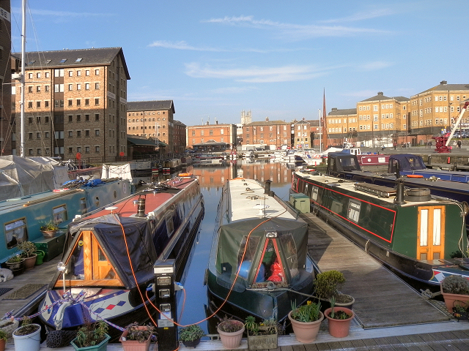

©Chris Allen geograph.org.uk/photo/1764218 and licensed for reuse under thisCreative Commons Licence © Copyright David Dixon geograph.org.uk/reuse.php?id=2836475 and licensed for reuse under this Creative Commons Licence
Student tasks

- Working with a partner for this activity, look carefully at the two photographs. Both photographs were taken at Gloucester Docks, but they were taken 31 years apart.

- What physical and human features can you identify? Use the two annotation sheets to label each image accordingly.

- Make a list of ten words/phrases to describe the scene in each photograph.
- Join with another pair and share your annotated images and lists of words/phrases.

- Were their annotations and lists similar to yours?

- Did they have any features or words that you could now add to your images or lists?

Annotation sheet

© ©Chris Allen geograph.org.uk/photo/1764218 and licensed for reuse under thisCreative Commons Licence

Annotation sheet

© Copyright David Dixon geograph.org.uk/reuse.php?id=2836475 and licensed for reuse under this Creative Commons Licence

