Introduction

The Lock Warehouse at the entrance to Gloucester Docks has witnessed many changes since it was built in 1834 for Messrs J & C Sturge, the leading corn merchants of that time. Following its industrial use as a warehouse, it later became the home of the Gloucester Antiques Centre but has now been converted to flats with commercial and retail use of the ground floor.

Student tasks

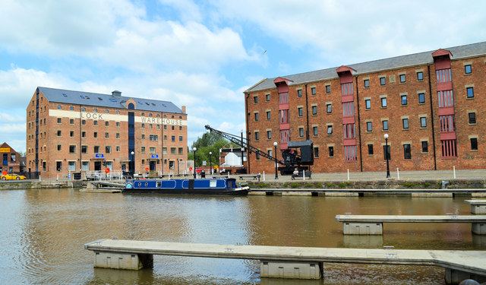
- Label five items of geographical interest on the image.

- Write five sentences to describe how the scene would have been very different in the past when ships were loading and unloading their cargo. At the start of the twentieth century, the cargoes included grain, timber, copper, sugar, iron bars, moulding sand and flour.

©Philip Pankhurst, 2014 under CC License

- Can you imagine living in a converted warehouse? Investigate properties for sale in Lock Warehouse in Gloucester Docks using zoopla.co.uk or a similar site.

