Introduction

A considerable amount of information can be gathered from a study of an old OS map. The map gives us a historical view of the land and allows us to see the changes that have occurred when compared to a modern map.

Student tasks

- What map evidence is there that this area was settled in ancient times?

- What map evidence is there that this was once probably an agricultural area?

- Use the map to identify ten sources of employment in 1901.

- How might this location have changed since 1901? How much trade do you think still happens at Gloucester Docks?
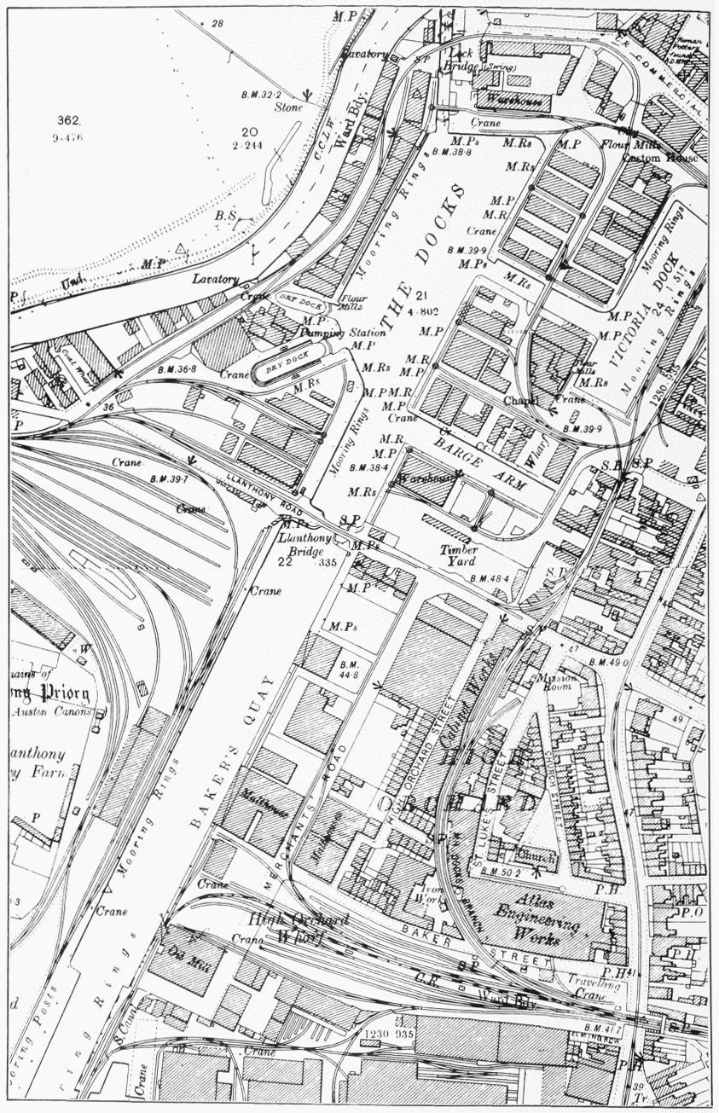

Map in public domain.

