The average calorie consumption in your country is 3,200 per person per day (about 14 Mars bars). You have got plenty of food and obesity is becoming a problem. Give one food to the country with the least. | The World Health Organisation (WHO) suggests that we need 2000–2400 calories per day to be healthy. Over one billion people in the world fall below this level and are described as malnourished. The average consumption in your country is only 1,580 per person (about 7 Mars bars). Gain two foods from a country of your choice. | Between 5-14% of your population is malnourished (they don’t get enough calories per day). Gain one food from a country of your choice. | The percentage of malnourished people in your country is below 5% and because of this, your people are healthy and they are able to work to contribute to economic development. The amount of food you have stays the same.
Your country uses 82% of its water for agriculture. You don’t have enough water (water scarcity), so choose the country with the most amount of water to give you one. | Your country uses 75% of its water in industry, e.g. producing cakes and cars. Your country has water to spare, so give one water to the country with the least. | Your country is mainly a desert and has very little water (physical water scarcity). Gain one water from the country with the most. | Your country is a newly emerging economy (NEE) and has little or no water scarcity. Keep the same amount of water.
Your country is developing quickly and needs more energy. Between 2003 and 2011, your country saw an increase of 53% in its consumption of energy. Choose the country with the most energy to give two energy to you. | Your country supplies much of the world’s energy, but its own consumption is relatively small. Give one energy to a country of your choice. | The annual consumption of energy per person per year is between 75–149 British thermal units (Btu). This is quite high, but not as high as energy consumption in the USA, which uses between 250-400 Btu.  You don’t produce enough energy yourself, gain one energy from a country of your choice. | The world’s richest one billion people consume 50% of the world’s energy, while the poorest one billion consume only 4% of the world’s energy. You are a LIC and use less energy, so give one energy away to a country of your choice.

- Compare and contrast the uses of water in HICs and LICs.

Look at this graph carefully.
- Describe the global consumption of energy by source. (Remember to use figures and proportions in your answer).
Renewable

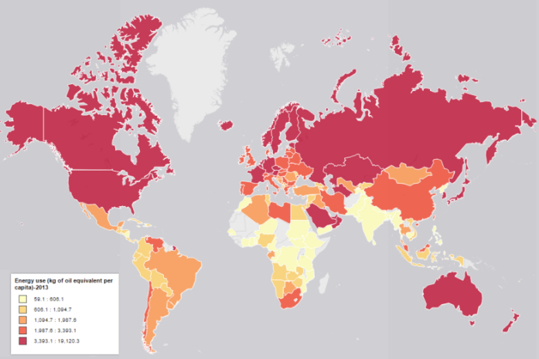
1. Describe who uses most energy and who uses least. Can you explain the reasons for this (refer to your answer for question one).

Look at the water scarcity map on the next page.
2. Describe and explain the global pattern of water scarcity (where is there little/lots, why?)

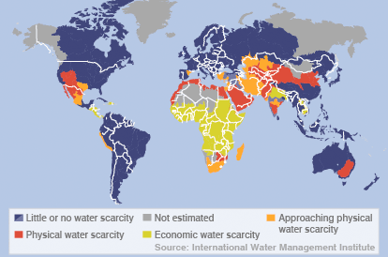
Look at the undernourishment map below.
3. Describe and explain the global pattern of undernourishment (where is there little/lots, why?)

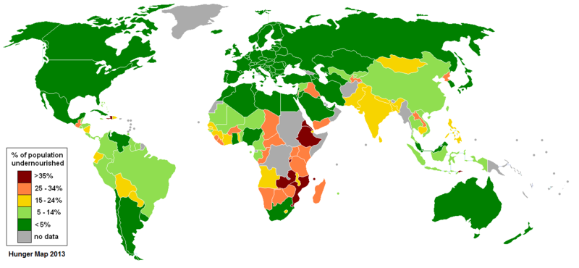
4. Using all the graphs and maps, try to describe and explain the links between energy consumption, water scarcity and undernourishment. What issues do you see for the future in terms of managing resources?

Image credits
- By Thomasjam [CC0 or CC0], via Wikimedia Commons
- By BBC NEWS [CC BY-SA 1.0 (http://creativecommons.org/licenses/by-sa/1.0)], via Wikimedia Commons
- By The original uploader was Lobizón at English Wikipedia (Transferred from en.wikipedia to Commons.) [GFDL (http://www.gnu.org/copyleft/fdl.html) or CC-BY-SA-3.0 (http://creativecommons.org/licenses/by-sa/3.0/)], via Wikimedia Commons

